🧠 x86 PROCESSOR BASICS (HOW THE CPU ACTUALLY RUNS THE SHOW)
Imagine the CPU as the brain of your computer.
But not a chill brain — a cracked-out microsecond freak that runs everything on caffeine and electricity. Here’s how it works:

🏛️ The CPU – Central Processing Unit
This is where all the thinking, math, and decision-making happens.
It has:
- Registers – tiny super-fast storage slots (think 32-bit pockets for numbers)
- Clock – keeps time like a heartbeat so stuff happens in sync
- Control Unit (CU) – the boss that decides what happens next
- ALU (Arithmetic Logic Unit) – the muscle that does all the math and logic ops (ADD, SUB, AND, OR, NOT, etc.)
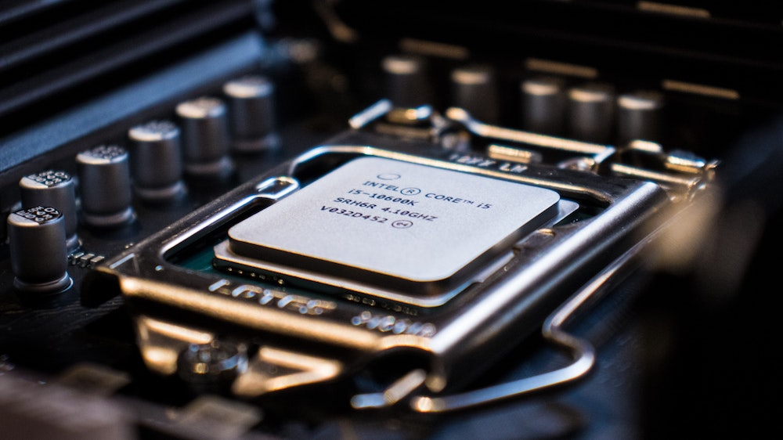

🔌 How the CPU Connects to the World
The CPU talks to the rest of the PC through pins on its socket. These pins connect it to buses — long electric highways carrying signals.
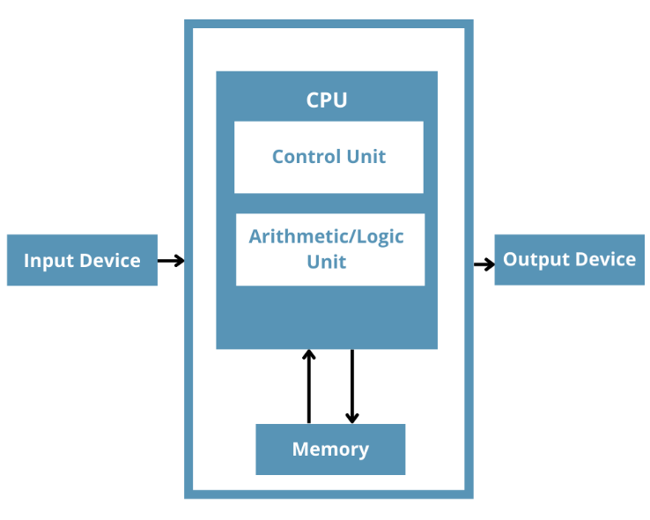

🔌The 3 main buses:
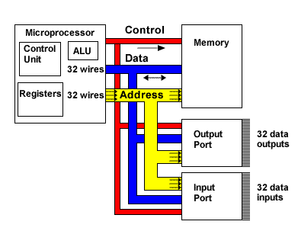

🟦 Data Bus
Moves the actual data and instructions between the CPU, memory and I/O devices.
The data bus is bidirectional, meaning information can flow in both directions.
The "width" of the data bus (how many parallel wires it has) determines how much data can be transferred at once.
A 64-bit data bus can move 64 bits of data simultaneously.

Analogy: The data bus is like a fleet of delivery trucks that transport goods (data) and mail (instructions) between the city hall (CPU), the library (memory), and various businesses (I/O devices). These trucks can deliver or pick up cargo.

🟨 Address Bus
Says where in memory we’re looking.
The address bus is unidirectional, meaning information flows only from the CPU to other components.
It carries the memory addresses or I/O port addresses where data is to be read from or written to.
When the CPU wants to access a specific piece of data or instruction, it places its memory address on the address bus, telling the memory unit exactly where to find or store that information.
The width of the address bus determines the maximum amount of memory the CPU can access.
A 32-bit address bus can address 2³² unique memory locations (4 Gigabytes).

Imagine your computer's RAM as a massive library, and each book in that library has a unique shelf and position. When the CPU wants to read a specific piece of information (a "book"), it doesn't just shout out the book's title.
Instead, it sends out the exact "shelf number" and "position" through the address bus. This "shelf number and position" is what we call a memory address.
This one-way communication ensures that the CPU can accurately request data from, or send data to, a specific spot in memory.

🟥 Control Bus
Uses binary signals (on/off) to tell devices when to send or receive. It synchronizes the actions and manages the flow of information among all devices attached to the system bus.
Think: "Hey RAM — CPU wants to read now!"

It carries control signals that dictate operations like "memory read," "memory write," "I/O read," "I/O write," "interrupt request," and "bus grant."
These signals ensure that devices don't try to use the buses simultaneously or perform conflicting operations.
The control bus is like the city's traffic light system.

Other Buses
⚫ I/O Bus
Handles data moving between CPU and input/output devices (keyboard, mouse, etc.)
Also called the Peripheral bus, considered part of the system bus, but, yeah, it’s a bit different coz its dedicated to transferring data between the CPU and the system I/O devices.
Modern systems often use high-speed serial buses like PCI Express (PCIe) for this purpose.

This bus is all about getting data to and from your input/output devices. Imagine:
- Keyboard Input: When you type "hello," that information needs to travel from your keyboard into the computer. The I/O bus is the route that data takes, like supplies being delivered to a restaurant. ⌨️➡️💻
- Printer Output: When you hit "print," the document data needs to go from your computer out to the printer. The I/O bus handles this, much like official documents being sent out to residents. 💻➡️🖨️

🧠 Memory – Where Programs & Data Live
All your running programs and variables are stored in RAM. But here’s the kicker:
The CPU can’t run them straight from RAM.
It always does this:
- Grabs the instruction from memory
- Brings it into the CPU
- Executes it
- Maybe sends a result back to memory
So, your code doesn’t run in RAM, it runs inside the CPU — one piece at a time, or in chunks.

📦 Buses Summary (Quick Table):
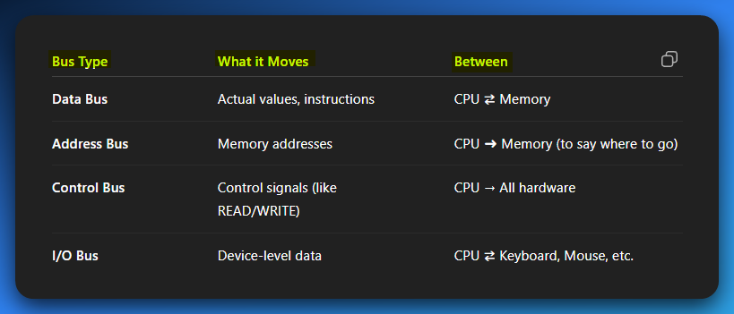
TLDR – Reverse Engineering Focus:
- Know the ALU is where bitwise ops live (AND, OR, SHL, etc.)
- Know that registers are the CPU’s playground — what you see in disasm (like eax, edx, rsi, etc.)
- Remember: instructions run inside the CPU, not memory. Memory just holds them until they’re needed.
- Buses = wires that move the ops around. If you’re watching malware move code into memory and jump to it — that’s this system in action.

